3.1 Detailed instructions for creating tar files and updating tar files to the ipfs

Prerequisite
- Docker
- IPFS

3.1.1 Creating TAR files

Note If you are planning to run TCPserver and Transcoding tool on a single machine you need to update the address with docker container IP Address

TCP Server

A : Configuring the files in Tcp Server

Before creating .tar files we need to configure the files for a particular package to communicate between the packages

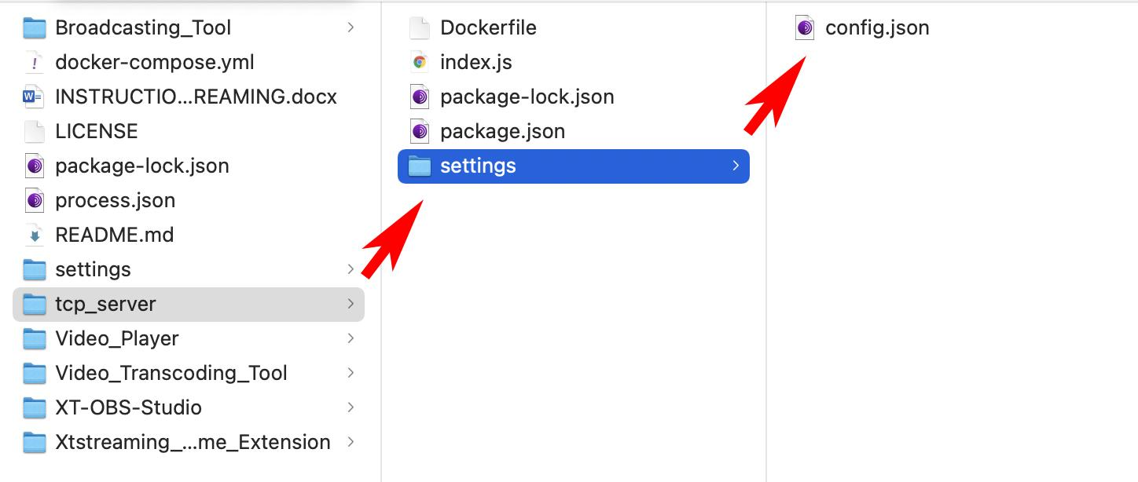

Go to settings folder and open config.json in a code editor

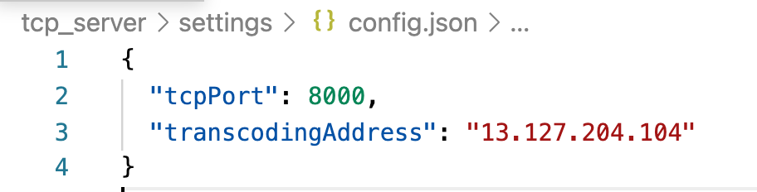

Update the transcodingAddress with the remote address of the machine which the transcoding tool is running.

When multiple connections are established on the tcp_server port we need to differentiate the connection between the OBS and Video_Transcoding_Tool

Update the tcpPort with the port which tcp_server to listen for connections

B Creating a docker image

To save .tar file first we need to create a docker image

To create the docker image

- Go to root of tcp_server folder and open terminal
- Run command docker build -t tcp_server .

C : Creating tar from the docker image

To create .tar file
- Go to the root of tcp_server folder and open terminal
- Run command docker save -o tcp_server.tar tcp_server

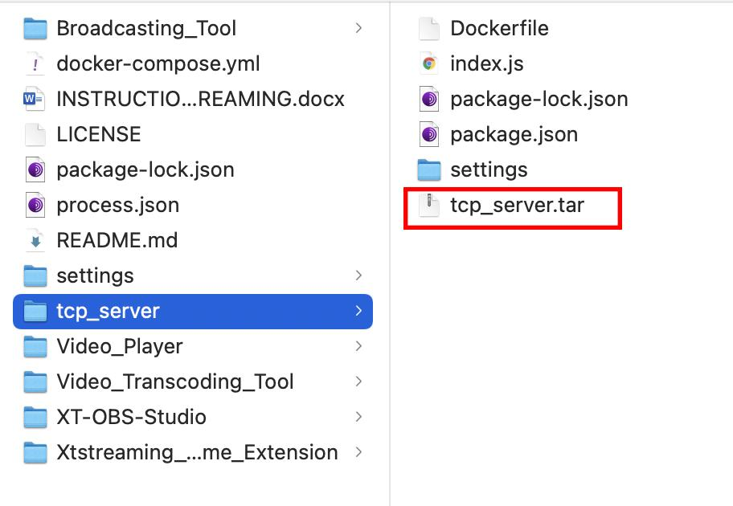

Now tcp_server.tar file has been created at the root directory of tcp_server.

Transcoding Tool

A: Configuring the files

Before creating .tar files we need to configure the files for a particular package to communicate between the packages

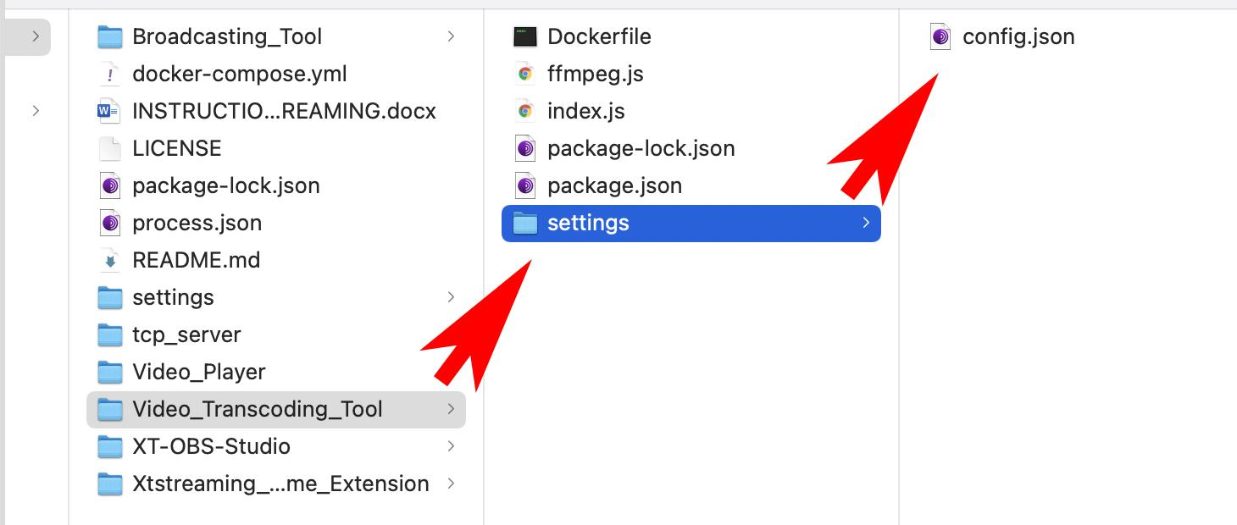

Go to the settings folder and open config.json in a code editor

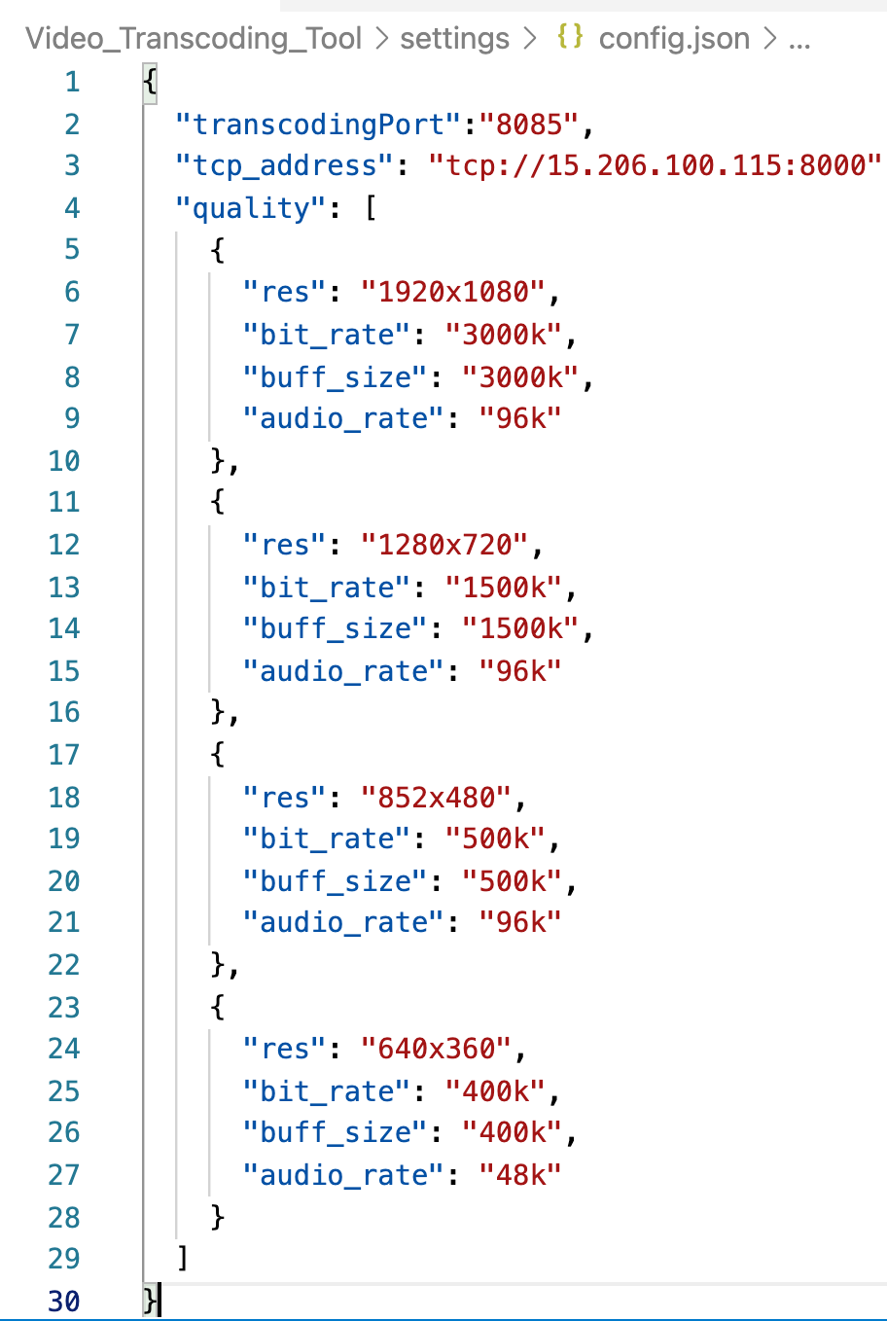

Update the tcp_address with the remote address of the machine which tcp_server is running.

In Video_Transcoding_Tool ffmpeg need to connect with tcp_server to receive data from OBS

Update the transcodingPort

B Creating a docker image

To save .tar file first we need to create a docker image

To create the docker image

- Go to the root of tcp_server folder and open terminal
- Run command docker build -t transcoding_tool .

C Creating tar from the docker image

To create .tar file

- Go to the root of tcp_server folder and open terminal
- Run command docker save -o transcoding_tool.tar transcoding_tool

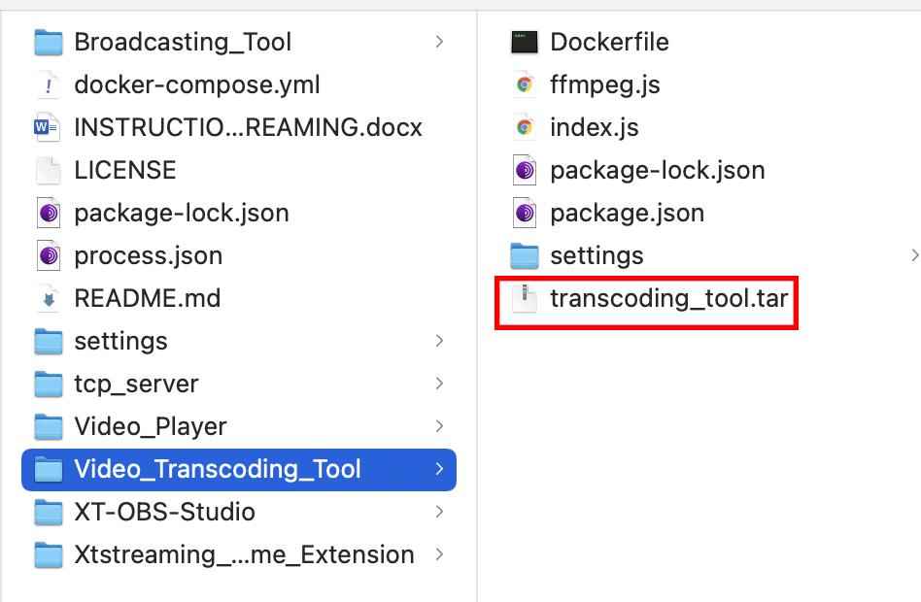

Now transcoding_tool.tar file has been created at the root directory of Video_Transcoding_Tool

3.1.2 Updating tar files to IPFS

Note: Need to wrap the file inside the directory when uploading to IPFS we can use -w in ipfs add to wrap files inside directory

- Copy the tcp_server.tar and transcoding_tool.tar file to the root of the xt-package-manager / verification directory which we created (REFER TO STEP-1 Creating TAR files)

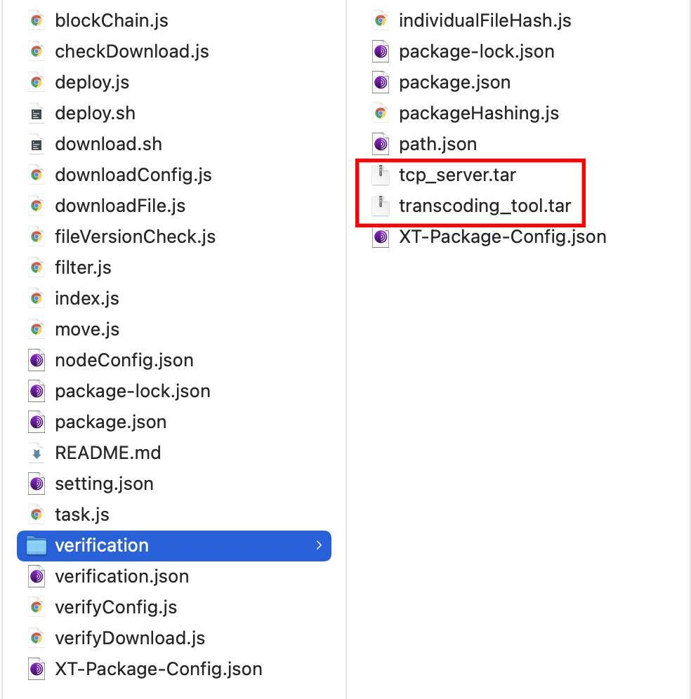

A Tcp_server

- Open terminal at the root of verification directory and run command

Ipfs add ./tcp_server -w

-w is used to wrap in a directory

Note the Cid code which will be used to update the XT-Package-Config.json

B Transcoding Tool

- Open terminal at the root of verification directory and run command

Ipfs add ./transcoding_tool -w

-w is used to wrap in a directory

Note the Cid code which will be used to update the XT-Package-Config.json

